**Project Design Phase-I**

**Solution Architecture**

|  |  |
| --- | --- |
| Date | 21-10-2022 |
| Team ID | PNT2022TMID38223 |
| Project Name | Fertilizers Recommendation System for Disease Prediction |
| Maximum Marks | 4mark |

Crop disease in plants is predicted and suitable fertilizer is recommended for better yield. The images of the diseased plants are obtained and it is preprocessed against the dataset of diseased plants. Deep Learning Algorithm is used to process the images and then it is evaluated. Then a model is built on the evaluations, it is then trained using no.of. inputs and predictions are given to the users which subsequently help in recommending the fertilizers.

The Convolution layers are used to classify and process the images and further helps in recommending the fertilizers. The image classification steps are:

* Image acquisition
* Preprocessing
* Segmentation
* Disease Prediction
* Fertilizer Recommendation

Solution Architecture:

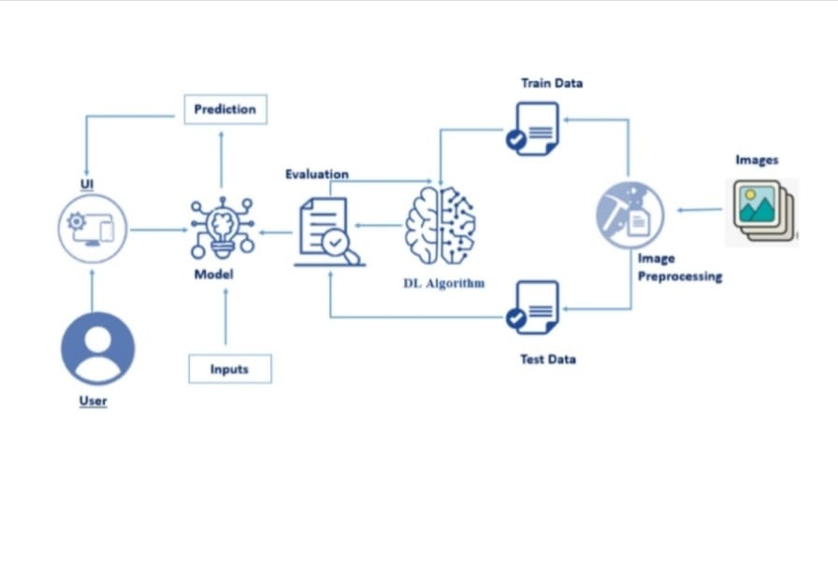The user used our laptop .it visible the Fertilizers recommendation system application he/she upload the disease image to the application the image is input. The input is going to model the model is evaluated. Then I am also adding the ANN and CNN layers. Next step is training the data and the image is preprocessing them test it the output is visible in our laptop.

Solution Architecture is a complex process -with many sub-processes- that bridges the gap between business problem and technology solutions. Its goals are